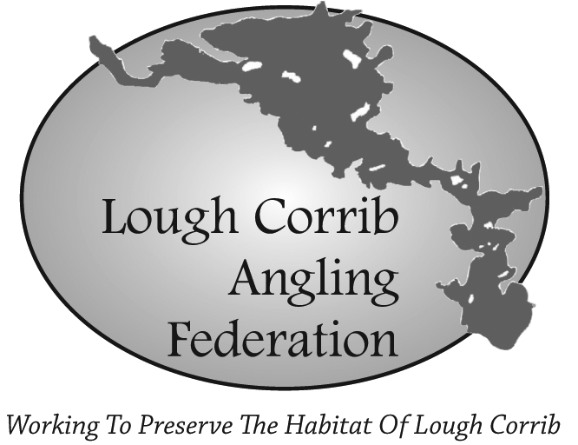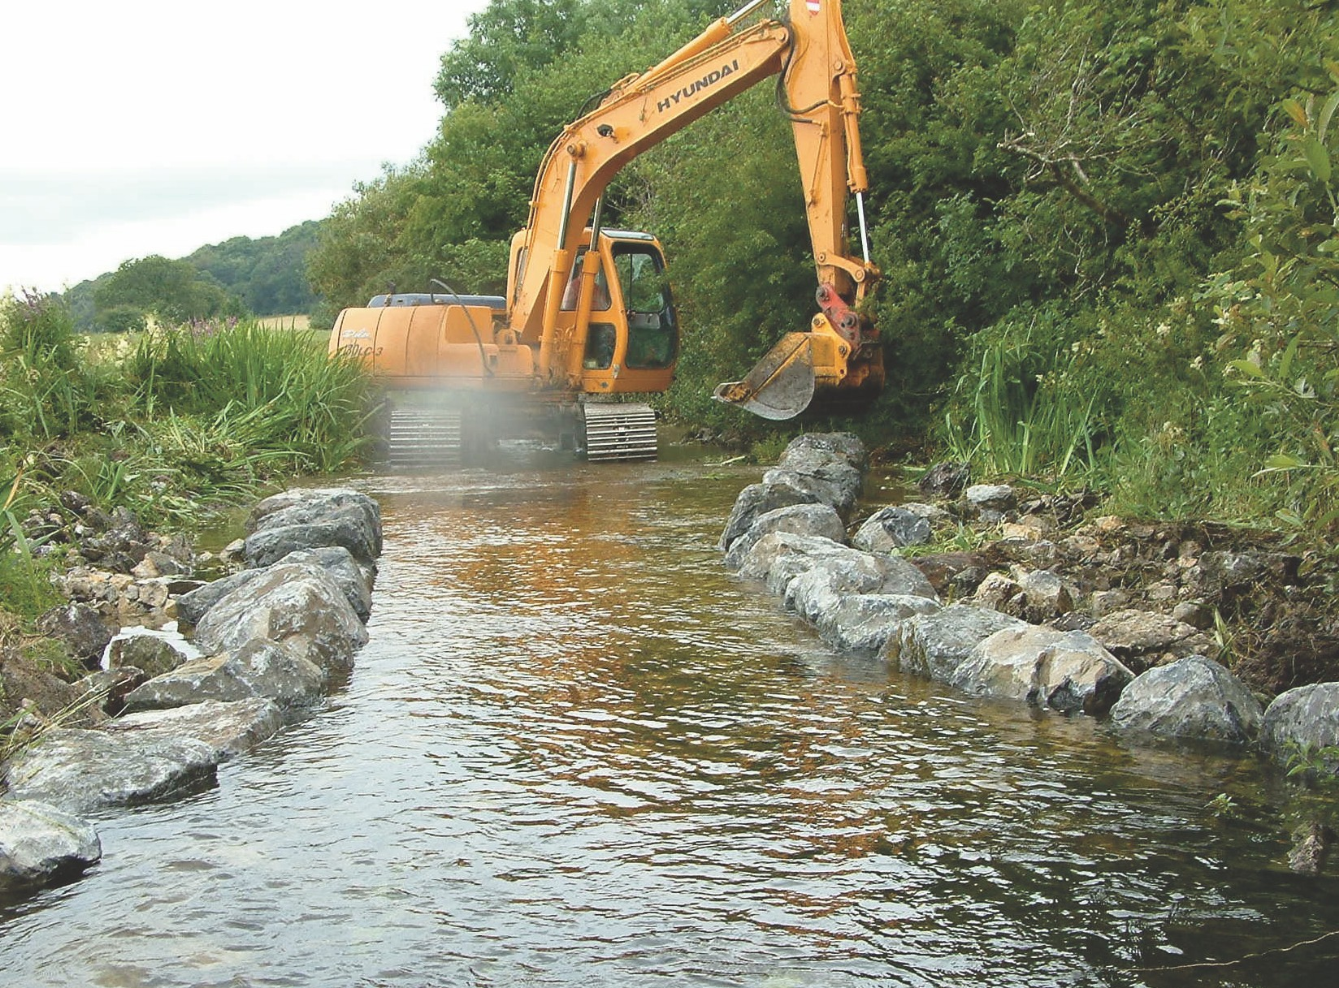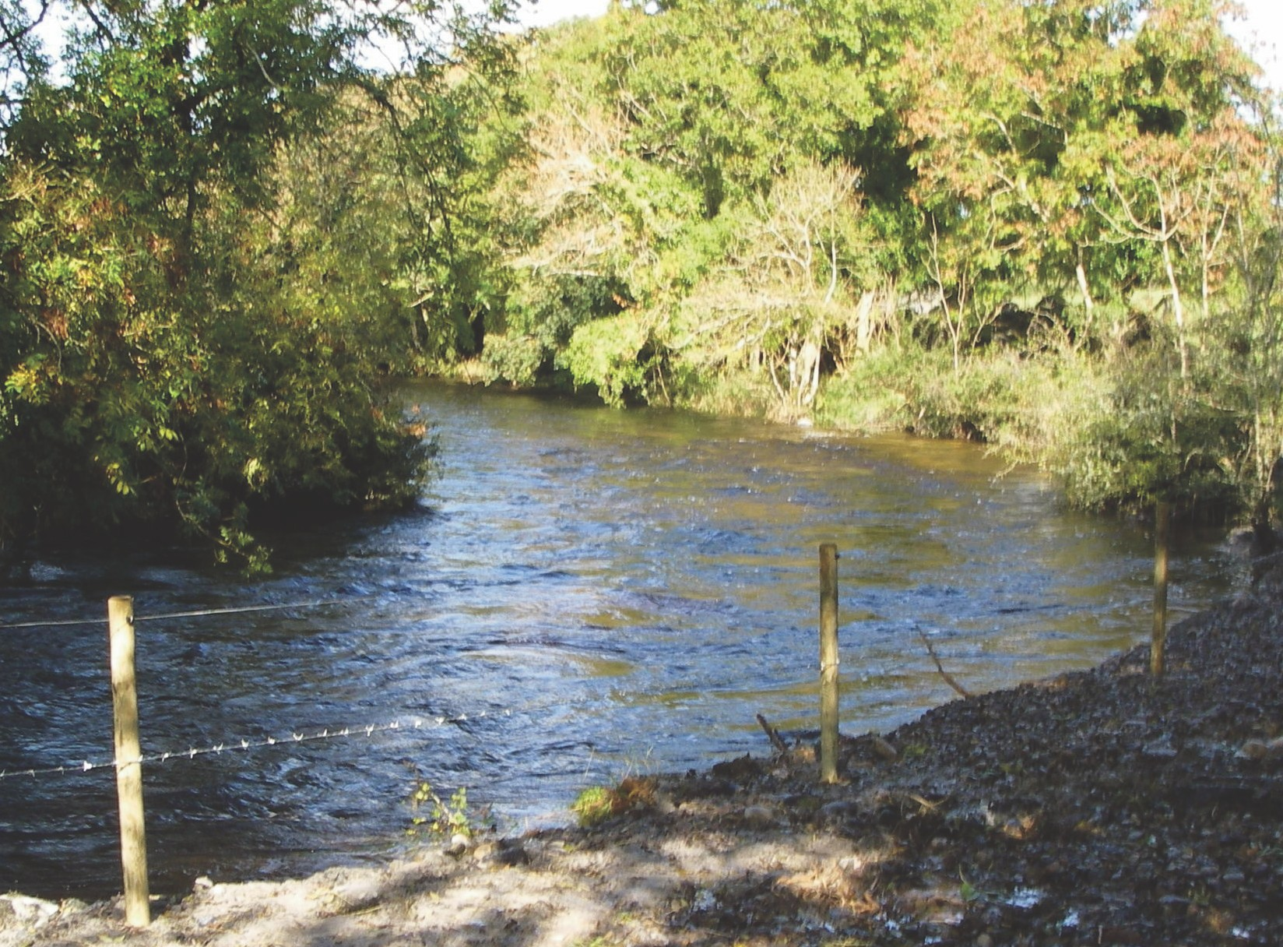

FEDERATION CLUBS!

An InterClub competition for Federation clubs will be run within the competition on the day. All clubs
should submit their four named anglers before the start of the competition.

All proceeds from this competition go to the maintenance and development of spawning and nursery areas in the Corrib catchment.
Lough Corrib Angling Federation

Federation Cup 2018
Hosted by Ballindiff Bay Anglers

24th June 2018 11.00am - 6.00pm
Luimnagh, Corrandulla, Co. Galway.

• Catch & Release Competition •

All proceeds to Cairde Loch Coiribe
(Lough Corrib Angling Federation Development Fund)
Competition Rules

Although entry is by pairs, this is an individual competition.
This competition will be run on a catch and release basis with points allocated on the length of fish. The limit for the competition is 33cm. All trout of this length and above shall score, fish below 33cm will not score.
Measurement will be from the tip of the nose to the FORK of the tail and will go to the next highest centimetre e.g. Trout measuring 33.4cm will be scored at 34cm, fish measuring 34.0cm will score 34cm. Each competitor will receive his own score card, on measuring a trout he shall have the length
verified by the other angler in his boat and shall mark his score card accordingly. All score cards to be presented at the end of the competition.
The individual with the greatest points total on the day will be deemed the winner. An open draw for par tners will take place on Wednesday 20th of June..
Telephone entries will only be accepted if written confirmation and entry fee is received before the closing date of
Wednesday 20th of June.

Rules
Official Entry Form
Lough Corrib Angling Federation

Federation Cup 2018

Boating Angler: Name: Address:
Phone numbers: Mobile: Home: I have read the Rules and agree to abide by them.

event of inclement weather or for any other reason. All entries are accepted subject expressly to this condition.
1. | Any competitor found trolling flies, baits or lures, spinning or dapping, will be disqualified. | Signed:  Angler: Name:
2. | Not less than two and not more than four flies will be permitted.
3. | All competitors must be ready to leave the shore at 11.00am.
4. | All boats must be inside the marker at 6.00pm.
5. | No boat may fish within 100 yards of the boat in front or cut in on a boat on a drift. |  | Address:
6. | A boating angler may not bring a boatman, two people per boat only.
7. | The Committee will not be responsible for accident/loss.
8. | The competitors fish at their own risk. | Phone numbers: | Mobile: Home:
9. | Only brown trout shall weigh in.
10. | The committee reserve the absolute right to postpone, alter or cancel the competition in the | I have read the Rul | es and agree to abide by them.

11. No proxy anglers allowed.
12. The individual having the greatest number of fish will qualify for any prize in the event of two or more anglers having equal points.
13. Fishing from the shore is not allowed.
14. The Committee reserves the right of entry.
15. All entrants supplying boats are expected to have knowledge of the lake and act in a safe manner. Boats to be in sound and safe condition.
16. Mobile phones may only be used in the event of an emergency.
17. Any infringement of these rules will automatically disqualify.
In the interest of safety all competitors should wear eyewear and headwear protection.

No exceptions or excuses accepted
Safety officer will be present on the day

Signed:

Entry Fee €25 Per Angler
Please make cheques payable to “Lough Corrib Angling Federation”

Entries to: Philip Comber - 086 2786301
Golden Bay, Clonbur, Co. Galway.

Denis Healy - 085 7540180

Competitors are reminded that it is a legal requirement to wear life jackets whilst afloat.

